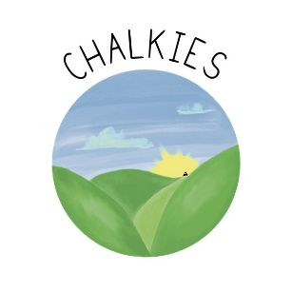

Safe sleep policy

Sudden Infant Death Syndrome (SIDS)is the unexpected death of a seemingly healthy baby for whom no cause of death can be determined based on an autopsy, an investigation of the place where the baby died and a review of the baby’s medical history.
In the belief that proactive steps can be taken to lower the risk of SIDS in childcare settings and that parents and childcare professionals can work together to keep babies safer while they sleep. Chalke Valley Play School will practice the following sleep policy:
- All key persons will receive training on our Safe Sleep Policy and SIDS risk reduction.
- Babies will always be placed on their backs to sleep unless there is a signed sleep position medical waiver on file. A copy will be given to the keyperson.
- FSIDS recommends that babies are placed on their backs to sleep, but when babies can easily turn over from the back to stomach, they can be allowed to adopt whatever position they preference when the baby turns onto his/her side or stomach.
- FSIDS recommends that using a dummy at the start of any sleep period reduces the risk of cot death. If a dummy forms part of your child’s sleep routine, it will always be used at sleep times. FSID recommends that the dummy should be stopped when the baby is between 6 and 12 months old.
- Visual supervision is always required. At least every 15 minutes a member of staff will visually check on the child; looking for the rise and fall of the chest and if the sleep position has changed. We will be especially alert to monitoring a sleeping baby during the first weeks the baby is in our care.
- Steps will be taken to keep babies from becoming too warm or over heating by regulating the room temperature, avoiding excess bedding and not overdressing or over-wrapping the baby; room temperature will be kept between 16-20 degrees.
- All babies must sleep in a cot or an approved bed/mattress. Babies may not sleep in a nesting ring, car seat, bouncy chair, pushchairs etc.
- Babies’ heads will not be covered with blankets or bedding; babies cots will not be covered with bedding.
- Loose bedding, pillows, bumper pads etc, will not be used in cots.
- Toys and stuffed animals will not be allowed in the child’s cot unless it’s a specific sleep aid.
- No smoking is permitted on the premises and key persons who smoke will ensure that their clothes and breathe do not smell of smoke when caring for caring for babies or any other children within the nursery.
- All outer clothing will be taken off children, no hoods, shoes or thick jumpers to be worn when going to sleep.

Policy Review
This policy will be reviewed on the date below by [insert name].
Signed: | ________________________________
Date: | ________________________________
Policy review date: | ________________________________

